16.72: a) As in Problem 16.71,

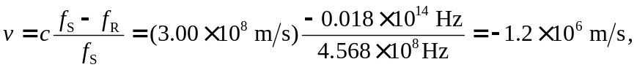

with the minus sign indicating that the gas is approaching the earth, as is expected since 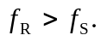 b) The radius is (952 yr) 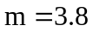 ly . This may also be obtained from (952 yr) 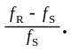 c) The ratio of the width of the nebula to 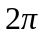 times the distance from the earth is the ratio of the angular width (taken as 5 arc minutes) to an entire circle, which is 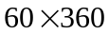arc minutes. The distance to the nebula is then (keeping an extra figure in the intermediate calculation)

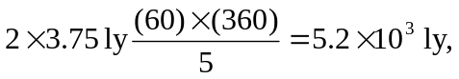

so the explosion actually took place about 4100 B.C

